ROS2 Commands
Additional Packages to install
sudo apt update && sudo apt install ros-dev-tools
sudo apt-get install ros-${ROS_DISTRO}-joint-state-publisher-gui
sudo apt-get install ros-${ROS_DISTRO}-xacro
sudo apt-get install ros-${ROS_DISTRO}-gazebo-ros
sudo apt-get install ros-${ROS_DISTRO}-gazebo-ros2-control
sudo apt-get install ros-${ROS_DISTRO}-ros2-control
sudo apt-get install ros-${ROS_DISTRO}-ros2-controllers
sudo apt-get install ros-${ROS_DISTRO}-moveit
sudo apt-get install ros-${ROS_DISTRO}-urdf-tutorial
sudo apt-get install libserial-dev
sudo apt-get install python3-pip
pip install pyserial
pip3 list | grep setuptools
pip3 install setuptools==58.2.0
pip install flask
pip install flask-ask-sdk
pip install ask-sdk
Changes to add in .bashrc file
source /opt/ros/humble/setup.bash
source ~/ws_moveit/install/setup.bash
export RMW_IMPLEMENTATION=rmw_cyclonedds_cpp
export LC_NUMERIC=en_US.UTF-8
VS Code Extensions | C/C++, CMake, CMake Tools, Python, XML, ROS, URDF
Important sudo commands  sudo apt-get update -y  sudo apt-get upgrade -y  sudo apt-get install <pkg_name>  sudo apt-get install <pkg>=<version>  sudo apt-get install <*pkg_name*>  sudo apt-get autoclean  sudo apt-get check  sudo apt-get help | Advanced Packaging Tool (APT)  Installs a specific package  Installs a specific version of a package  Installs all packages with spec. key  Cleans retrieved files from local repo  Diagnostic tool to check dependencies  Displays built-in help

Workspace Creation
Any ROS project begins with making a workspace. In this workspace, you will put all the things related to this particular project.
mkdir -p ~/<ws_name>/src  cd ~/<ws_name>/  colcon build | To create a new workspace and build it. The ‘colcon build’ should always be done from the root of the workspace
cd ~/<ws_name>/  rm -r build/ install/ log/  colcon build | To delete the old build, install and log directories and then build the workspace newly to resolve some unusual build errors

Installing Packages
Basically 2 types of packages can be installed

1. a stable, easily installable debian package
sudo apt install ros-humble-<debian_pkg_name>

2. an unstable git package, which is less tested but more cutting-edge
git clone -b <branch_name> <repository_url>
ros2 pkg prefix <pkg_name> | This is a helpful command to troubleshoot problems with a ROS workspace. If this command can’t find the package, other ros nodes can’t find either.

Creating new Packages
The basis of ROS communication is that multiple executables called nodes are running in an environment and communicating with each other in various ways. These nodes exist within a structure called a package.

Package creation in ROS 2 uses ament as its build system and colcon as its build tool.
The contents of a CMake packages are as follows,
- CMakeLists.txt file that describes how to build the code within the package
- include/<package_name> directory containing the public headers for the package
- package.xml file containing meta information about the package
- src directory containing the source code for the package

cd ~/<ws_name>/src  ros2 pkg create <package_name> \  --build-type ament_cmake \  --license Apache-2.0 \  --dependencies rclcpp  cd ~/<ws_name>  colcon build | To create a package and build it  C++ pkg: ament_cmake  Python pkg: ament_python  Various options like build-type, license, dependencies can be given either directly in the command line or added in the package.xml file.  The package should be created inside the src folder present inside the root of the workspace
. install/setup.bash | To source the setup.bash file present inside the ‘install’ folder. This should be done to make the current terminal and ROS2 to know about the existence of the workspace we created.
Creating new Nodes
Nodes should be created within the src folder of the package, i.e.,
worskpace → src → package → src → node.cpp
Some common parts of a C++ node and their functionalities are as follows,
#include <rclcpp/rclcpp.hpp> | Adds the ROS C++ header file
int main(int argc, char* argv[])  {  } | Adds a main function. The rest of the code will go inside this function
rclcpp::init(argc, argv); | Initializes the ROS CPP middleware interface. This has to be called once per process and before anything else ROS-related
auto node = std::make_shared<rclcpp::Node>(“node_name”); | Creates a ROS node instance
RCLCPP_INFO(node→get_logger(),”msg”); | Prints a message using ROS print tools. There are 5 levels of logging:  RCLCPP_DEBUG,  RCLCPP_INFO, RCLCPP_WARNING, RCLCPP_ERROR and RCLCPP_FATAL
rclcpp::spin(node); | Keeps the node alive and prevents exiting the program automatically.

Steps after Node creation
Each package is made up of one or more executables called Nodes. Once the node is created, we need to add instructions for building it into an executable program. This is done by adding appropriate instruction inside the CmakeList.txt file inside the package folder.

add_executable(<node_name> src/<node_name>.cpp)
ament_target_dependencies(<node_name> <dependency1> <dependency2> ...)

These lines should be placed inside the CmakeList.txt, after the section labeled # find dependencies and before the ament_package() call.

The flow of a CMakeLists.txt file is,
1. Find all dependencies the current project requires,
2. Declare the targets the current project is creating,
3. Finally specify extra information such as how to test the targets and things that projects making use of this one need to know.

Now we have told the Cmake about the node executable and how to build it, but to actually run it, add the following lines inside the CmakeList.txt, after ament_target_dependencies() but before the ament_package()

install(TARGETS <node_name> DESTINATION lib/${PROJECT_NAME})

Now, build the workspace again and then source the bash file.

ros2 run <pkg_name> <node_name> | To run the created node.
ros2 node list | To list all the active nodes

Nodes dependent on other packages
the other hand, if the node in the current package, depends on another package, the following changes have to be made.

1. In the <node_name>.cpp file:
#include <pkg_name>

2. In the CmakeLists.txt file:
find_package(<pkg_name> REQUIRED)
add_executable(<node_name> src/<node_name>.cpp)
ament_target_dependencies(<node_name> <dependency1> <dependency2> …)

3. In the package.xml file:
<depend>pkg_name</depend>

Topics and Messages
Messages are one-way communications which are sent over channels called Topics.
Typically one node publishes messages on a topic and another node subscribes to messages on that same topic. Typically, the topic names begin with ‘/’ i.e., /topic_name

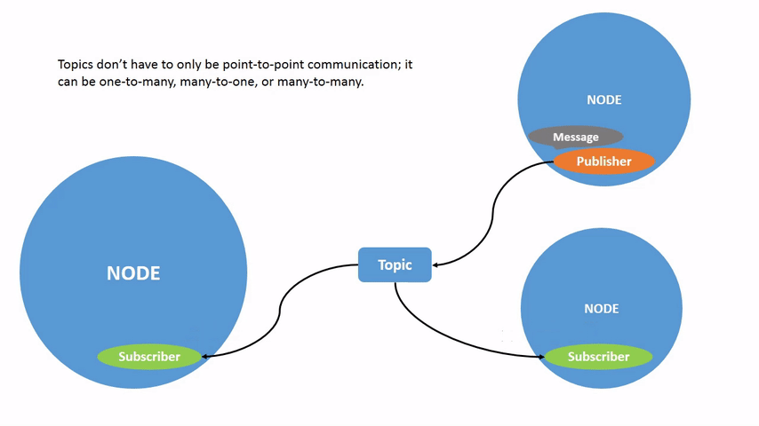
rqt_graph | To visualize the changing nodes and topics, as well as the connections between them
ros2 topic list | To list all the active topics
ros2 topic list -t | It will return the same list of topics, but with the topic type appended in brackets
ros2 topic info /<topic_name> | To get information about a specific topic like its Type, Count of Publishers and Subscribers
ros2 topic echo /<topic_name> | To see the data being published on a topic
ros2 interface show <msg_type> | To get the details of the specific message type
ros2 topic hz /<topic_name> | To view the rate at which data is published to the topic

